Ready, steady, speak-online: Student training in the use of an online synchronous conferencing tool
Authors, XX University, UK

Abstract

With the increase of online language teaching the training needs of teachers have long been established and researched. However, the training needs of students have not yet been fully acknowledged. This paper focuses on learner training as preparation for language classes where online synchronous conferencing is used. It presents an action research cycle consisting of planning and conducting training sessions, analysing evaluative feedback, reflecting on changing needs, re-designing the provision and re-iterating the sessions. The research focuses on three iterations of the learner training conducted over a 21-month period, drawing on almost 500 completed student feedback responses.
The findings show that students considered the training sessions helpful in establishing how online language classes operate and gaining confidence to participate actively. Specifically they benefited from using their L1 to practise techniques for projecting their social presence in an online communicative situation, compensating for the lack of features such as body language, non-verbal communication, and spatial impressions. As for their teachers, the research demonstrated a need to reflect on the terminology used to explain CMC tools.
The article concludes with good-practice recommendations for the provision of learner training in online language classrooms.
Ready, steady, speak-online: Student training in the use of an online synchronous conferencing tool
Authors, XX University, UK

Introduction

This paper reports on the provision of a large-scale learner training programme at a distance learning university in the UK where web-based, online synchronous conferencing is used for language classes in a blended teaching context.

The XX University (XX) in the UK has been at the forefront of developing and implementing innovative approaches to distance language learning since 1997. This has included the introduction of audio-graphic conferencing and videoconferencing for language teaching. Since 2009 classes have been offered in blended mode, partly face-to-face and partly online using a web-based conferencing tool.

Whereas the need for training teachers in the use of online tools for language teaching has long been established and researched, students, on the other hand, have often had to rely on their pre-existing knowledge and competence in ICT without the need for training being acknowledged. In this paper we recognize the need to train learners so that they can make the most of online learning environments, even though distance students are in general prepared to choose their own support modes and methods and select the most appropriate help from sources available offline and online. To support our learners, basic introductory training in the use of online conferencing is now offered to all XX University language students, who number approximately 9,000 overall.

This study follows an action research cycle of establishing a training programme, collecting evaluative feedback, re-designing the provision and a reflective re-iteration of the programme. The authors were involved as trainers, organisers, negotiators, and change initiators in the training described in this paper. The action research approach to this study seemed the most appropriate. It enabled us to collect evidence at the same time as instigating change and improving our practice and our learners’ training experience. The cycles of reflection and change show clearly that learner training benefits from systematic evaluation and updating. Our research as well as our teaching is based on a socio-cultural approach to language learning that centres on learners and their active construction of knowledge and collaborative development of skills.

The next section of this article will set the study in the context of online synchronous language teaching and learning. The following Section will present the background and context of online teaching and learning at the XX University by examining how language teaching has changed over time. It will also set out the aims, content and organisation of the training programme for using the online conferencing tool. Then, following a short outline of the action research framework and data collection methods, the findings of the study will be presented and discussed. The final section contains our conclusions, drawing together findings and improvements and making best practice recommendations for further use in the wider area of online language teaching and online learner training.

Literature

The benefits of using synchronous spoken communication over the internet have been researched for some time. Since 2002 the Department of Languages at the XX University has used a variety of tools to communicate with students in online classes and allow them to practise speaking in real time. The first of these tools, Lyceum , was developed in-house and has formed the basis of numerous studies. While some dealt with the benefits of audio-graphic conferencing as such , others focused specifically on the comparison of online classes with the more traditional face-to-face variants . In terms of researching the student experience of these technologies, within and outside the XX University, this has brought with it more sophistication in observational techniques , experimental set-up and methodologies chosen .

In the face of rapid technological development the need for language tutors to receive adequate training for their new teaching environment has been acknowledged and seen as worthy of investigation . Following the increasing popularity of online synchronous language teaching and learning the focus of papers written about online teacher training has moved from an initially explanatory stage , presenting the novelty of tools and functionalities, to an instructional “How-to” stage , giving guidance to potential users of the new technologies, to ever more diverse and specific training suggestions for the online language teacher , focusing on pedagogy and interaction rather than technology. Research and evaluative projects have been conducted to establish the best ways of training online language teachers . Specifically, the use of multimodal audio-graphic online environments that allow the interaction, supplementation, and support of different modes, has received attention in recent years .

For a long time learners’ training needs were seen as a practical challenge but generated little relevant research. Institutions - and to some extent teachers - relied implicitly on the existence of a “net-generation”, of so-called “digital natives” and their pre-existing knowledge and digital competence. However, this assumed digital competence does not guarantee successful online learning skills. At the XX University the situation is more pronounced: with a majority of mature students digital competence cannot be taken for granted. Therefore, ICT literacy is mentioned explicitly in the XX University definition of “graduateness” and training in ICT skills is recognized as necessary for the XX University’s cohort of part-time, distance students.

The technical challenges of using synchronous multimodal tools for language learning are just one aspect of online learning . Even students who are “digital natives” are not necessarily able to use online tools proficiently and to their best advantage for the purpose of learning. Acquisition of technical skills, e.g. conducting sound checks, using textchat, speaking and dealing with audio problems, are necessary conditions for online language learning and – simultaneously – also build students’ confidence in using the software.

A crucial aspect of technology-mediated communication is social presence: “the degree of salience of the other person in the interaction and the consequent salience of the interpersonal relationships…” . Social presence changes with the awareness of those using communication media, and is influenced not only by the actual technical affordances but also by the expectations of the interlocutors. This is particularly relevant for language learning as communicating in an L2 (second language) means having to compensate for a lack of vocabulary and fluency. Communication mediated not only by a foreign language but also by technology is prone to a loss of social presence, a lack in depth of communication and flexibility of content. To make this type of communication successful for online learning it is important to train users in the skills necessary to create and sustain a feeling of social presence during online classes. These skills are not just receptive, i.e. understanding and reacting to social presence indicators such as pointing, but also productive, i.e. deliberately and strategically projecting social presence, e.g. by using emoticons or video transmission .

The use of social presence indicators can help to make online communication more natural and improve the learning experience of students , e.g. by managing turn-taking and the projection of video images . The affordances of the chosen tool will influence what is possible and easily achievable for different learner types in online learning situations . Knowledge about the tool’s affordances can also help to clarify where different modes of online communication (e.g. textchat, audio, video) can potentially compete against each other and thus make communication more difficult, and where modes can be deliberately employed to compensate for each other, thus facilitating communication .

In supporting students to practise online communication first in their own language before expecting them to use it in the more challenging environment of an online second language class we are providing scaffolding for the learners. In socio-cultural theories, learning is seen as “constructing” meaning and understanding ; learners interact with their environment (which is social, physical, and often mediated by technology, etc.) to change their understanding of the world, ideally helped by others (peers, more advanced peers). This help, if planned and intentional, can be seen as scaffolding. However, it is still often up to learners to engage fully and actively in the process of working out for themselves how online tools function and how they can be utilised to meet their own needs.

Online learning lends itself particularly to this form of constructivist learning : once students have experienced the software in a successful communicative event, they are more likely to be able to use it again (and to remember how to access the online learning space) having been motivated by their experience of success.

The constructivist learning experience, however, was not limited to our learners: trainers and training organisers also went through the experience of finding out for themselves the best use of the tools for online language learning and working collaboratively to establish how best to teach the necessary skills . Following an Action Research Cycle (“plan – act – observe – react”) , the authors and their colleagues created, conducted, evaluated, and improved online training to prepare language students for their participation in online classes. Our reactions to students’ needs and our own growing understanding of online language teaching and its necessary aspects of student training will be presented in the following parts of the paper.

Background and Context of the Study

Distance Language Learning in the XX University

Since its creation in 1969 the mission statement of the XX University is to be ‘open to people, places, methods and ideas’. The XX University has currently approximately 200,000 students, of which 9,000 are learning a second language. When modern language courses were introduced in the 1990s they initially drew on purpose-written teaching packs incorporating audio and video materials which students worked through, guided by a study calendar and with teacher support .

Students at the XX University are mainly mature adults in work who study part-time for a degree or for self-improvement. Their motivation for choosing language courses is diverse, as is their age, socio-cultural background, and their persistence in study . As adult distance learners, our students need to be highly self-organised and self-regulated but at the same time they can rely on established, sophisticated support systems.

The teacher’s role includes marking assignments, teaching through detailed feedback, as well as answering individual queries. They also provide regular classes, an important part of the support offered to language students since they create an opportunity to interact orally in the target language. So although attendance is not compulsory it is highly recommended . Alongside meeting peers and teachers in classes, students have always been actively encouraged to draw on their peers for support and language practice outside classes, for example through forming independent study groups .

Changes in technology have resulted in new models for the provision of materials, including the development of a Moodle platform (see Figure 1). Language courses now have a dedicated website with a calendar and resources. This allows for online provision of materials and activities with a variety of tools, such as forums, quizzes, wikis, blogs and glossary; in short, it creates a more collaborative learning environment.

Figure 1
Time line: technologies used for teaching and learning languages at the XX University
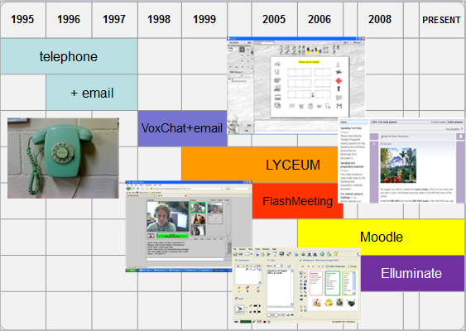

Technology also enabled classes to be offered online, initially using Lyceum, whose interface adopted the metaphor of a college building with multiple classrooms and included live spoken and written exchange as well as shared whiteboards . This made it possible to mirror larger and small group work as in a real classroom. The multimodality of the environment supported language learning in particular . This tool offered students an online alternative space for independent study sessions. Introductory “Lyceum for All” sessions were offered to facilitate this.

Selecting an Appropriate Tool for Language Teaching and Learning

In 2008 the XX University, updating its online provision in line with technological developments, sought a new online tool not only for the requirements of language teaching but also scalable for up to 200,000 students in a variety of faculties. Selecting the appropriate tool for online communication is essential for any teaching, but in the case of online language classes some additional factors have to be taken into account. These also have implications for student training (see Table 1).

Table 1
Implications of choosing a tool for online language teaching and learning
Questions for consideration | Implications for language teaching and learning | Implications for student training
How faithful is the sound reproduction? | Language learners, particularly beginners, need accurate models for the target language sounds. | Trying out the tool in L1 enables learners to judge the quality of reproduction.
Does the tool allow use of language learning methods, e.g. spontaneous speaking, overlap of turns and chorus practice? | There may be a tension between language teaching pedagogy and what online technology can offer, e.g. the advantages of full duplex over half duplex audio need to be considered. | Becoming aware of the limitations and affordances of the tool and practising possible compensatory moves (e.g. if simultaneous talking is not possible, use text chat or hand-raising to ask for your turn).
How flexible is the tool in presenting foreign characters? | Written scaffolding is frequently used for speaking tasks, e.g. semi-structured dialogues for role-plays, vocabulary support for open responses. | Providing information about accented characters, using ASCII codes and importing Chinese characters with copy and paste.
How many different options for presenting materials does the tool offer? | Different learners may prefer materials presented in different ways, e.g. aurally, textually, visually. | Becoming aware of own ways of learning and how the tool affordances match them (e.g. desktop sharing vs. uploading documents).
What affordances are there for the facilitation of small group work? | Language learners need to practise in pairs and small groups to achieve a maximum exposure to language, and opportunity for producing target language output. | Trying out small group work areas (“breakout rooms”), making needs known to change practice of teachers and developers (e.g. ask for learners to be able to move to breakout rooms independently).
Can images be presented, imported and created during classes? | Language teachers frequently use visual cues to support vocabulary acquisition, feedback (e.g. by using emoticons), and cultural understanding. | Personalising own learning to remain motivated and engaged (e.g. upload own images with “meanings that matter” to them).
Is a video camera available? | This can offer teachers the option of showing not only themselves but also authentic artefacts and objects from the target culture to stimulate discussion and cultural awareness. | Deliberately enhancing sense of social presence by sharing own image.  Coping with limitations (e.g. lack of lip synch for pronunciation modelling).
Is it possible to integrate a web tour to guide students to authentic online documents and sites? | Use of authentic and culturally relevant stimuli is important in language acquisition as cultural learning cannot be separated from language learning. | Learning the discipline of sticking to a task brief without getting lost in cyberspace or becoming disconnected from the group.

Various tools were considered, including meeting tools, specific conferencing tools and tools specialising in desktop or application sharing, but in the end Elluminate, a web-based online video-conferencing tool specifically designed for teaching, which matched most of the requirements referred to in Table 1, was selected to replace the server-based Lyceum.

The Student Training Programme: aims, content and organisation

The adoption of Elluminate as the standard conferencing tool coincided with the introduction of blended tuition, defined by Nicolson, Murphy and Southgate as a mixture of traditional face-to-face and online learning experiences. As a result all language students would now use this conferencing tool for some classes, and could also do so for independent speaking practice.

It was therefore imperative that all teachers and students became familiar with the basic functionalities of the new system. The student training took two approaches: 1) self-access text-based training materials and 2) online live training sessions in an online ‘room’ on a website set up especially for student training. This allowed access for students from all language courses.

The online live training sessions had two short term aims:
- introduce participants to the online synchronous virtual classroom tool;
- give participants confidence to attend online classes using this tool.

They also had a medium term aim of enabling students to meet other students with a view to setting up independent study sessions.

The one-hour live training sessions were conducted in English and allowed all learners to experience the basic functionalities of the new tool. This meant that they were only mediated by the technology but not by the language as well. The training provided practice in how to speak using the microphone, use of the voting function (tick or cross), use of the textchat, “hand-raising” to take turns, as well as emoticons. Students were given a first experience of whiteboard tools and facilitators also introduced other functionalities, including the webcam, and gave advice about further training and sources of help.

Sessions were conducted by a team of eight experienced online teachers. Each teacher acted as facilitator to a group of up to 20 students, taking the group into a ‘breakout room’ within the main online conferencing room (see Figure 2).

Figure 2
Trainer view with welcome screen in main room
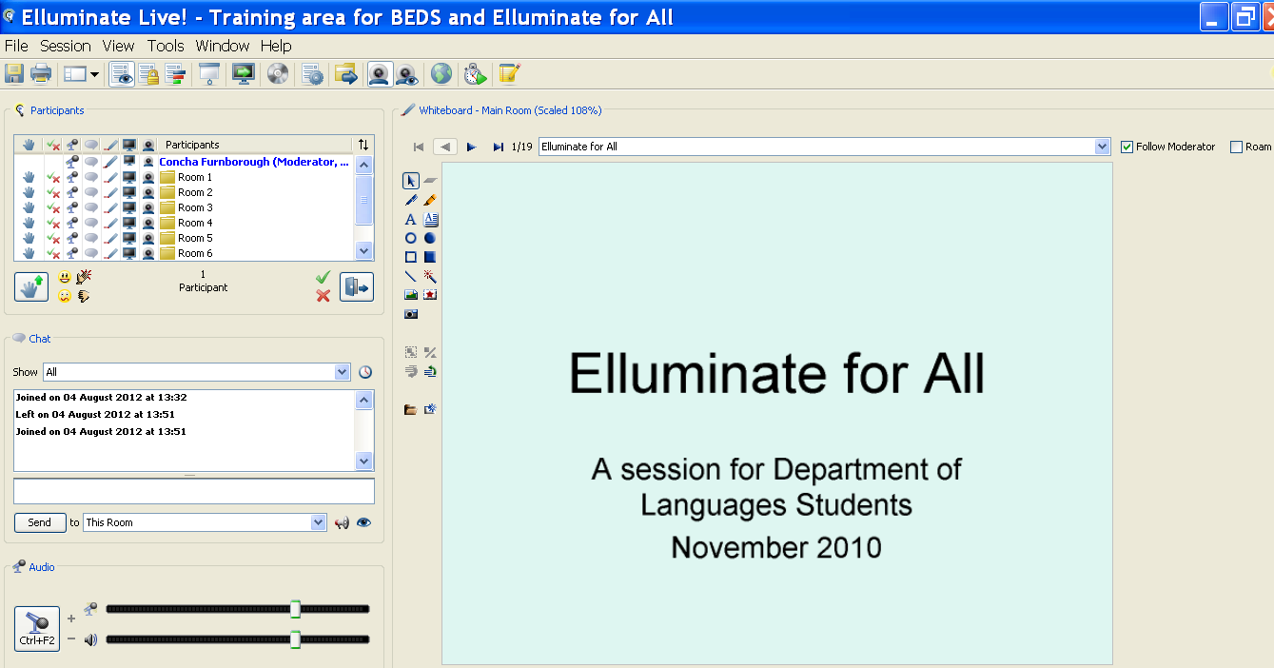

At the end of the session students were encouraged to stay on in order to meet others studying the same course, with a view to organising future independent study meetings in which to practise interacting in their target language (see Figure 3).

Figure 3
Elluminate room student view
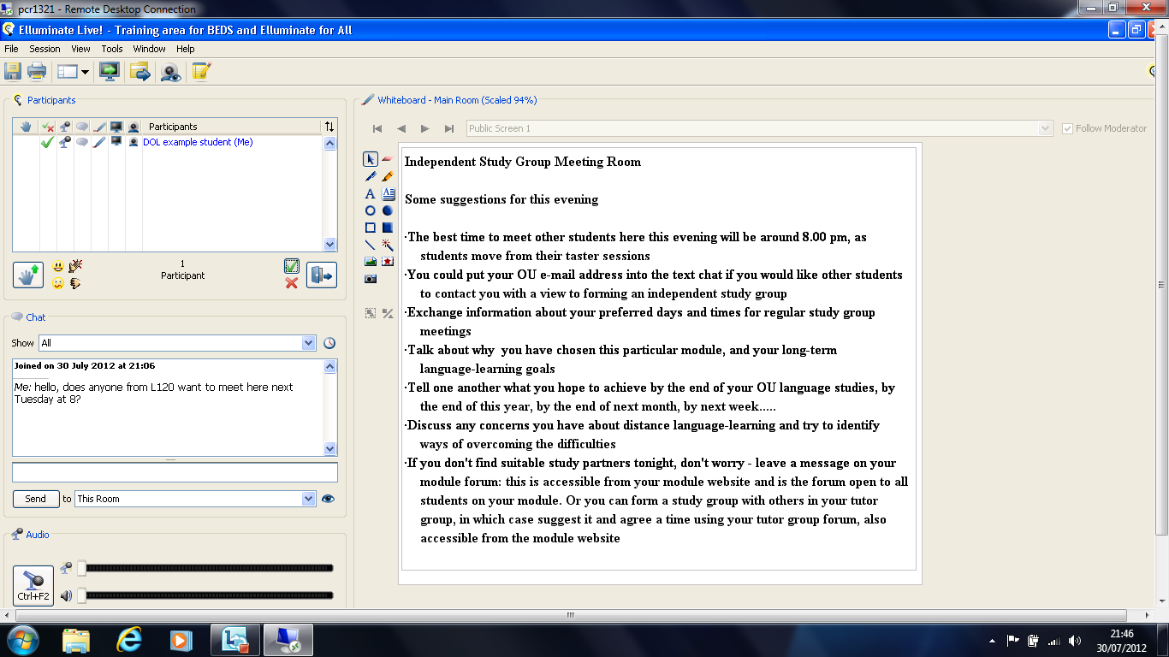

The invitation to participate in an “Elluminate for All” introductory session in English was posted in the news section of each course website. It also included guidance on accessing the online training space. Sessions were offered on different dates at the start of the course. Students registered an interest in attending by sending an email to a dedicated email box. For organisational purposes numbers for any session were restricted to 100 and any additional students were asked to pick an alternative date.

This student training constitutes the action stage of the action research cycle. The next sections of this paper will deal with the observation or evaluation stage and the reaction or revision stage in subsequent iterations of the training.

Methodology

This study is based on training sessions for the online live room conducted over a 21-month period. It draws on the findings of almost 500 completed student feedback questionnaires (see Table 2). We report on the developing action cycle that comprised the first set of sessions, the student feedback received, changes introduced at the next planning stage, and two subsequent sets with their corresponding student feedback, reflection and implementation of changes (reiteration of the action phase). During the reflection stages, the training team’s own understanding of the nature and purpose of the online learner training changed and developed. This is shown in the improvements achieved and discussed in detail in the conclusions to this paper.

Table 2
Data collection and response rate
Course start dates | Number of questionnaires sent out | Number of  responses | Return  Rate
February 2009 | 830 | 169 | 20%
November 2009 | 595 | 178 | 30%
November 2010 | 700 | 152 | 22%
Total | 2125 | 499 | 23%

Feedback was obtained from students through a brief online questionnaire using SurveyMonkey (See Appendix). The same questionnaire was sent six to eight weeks after each course had started to all students who had registered their interest in attending a training session. Over the whole period 499 responses were obtained.
These formed the basis of the evaluation phase of the action research.

The survey set out to identify how the student training sessions were rated by participants, and specifically to what extent they had met the three intended outcomes (introduction to the online synchronous classroom, giving confidence to attend online classes, and meeting others with a view to setting up independent study sessions). In order to establish general IT-readiness a tick list of popular computer uses, e.g. reading the news online, was included. The survey also sought to establish other sources of advice and guidance for online learning accessed by respondents. Students were also invited to share their views not just on the sessions themselves, but also on related issues, such as their attitude to the inclusion of online teaching as an integral part of the teaching strategy.

The reiteration of the survey as an inherent element of the action research cycle allowed for an element of longitudinal comparison and identification of certain trends. Materials and procedures for the training sessions were revised and improved (as described in the section on Findings and Discussion) before the next iteration of the training, based on the observation of the training and the feedback received.

The research was conducted in adherence to BERA (British Educational Research Association) guidelines, and respondents remained anonymous.

Findings and Discussion

Respondents’ Previous Use of Computers

In order to establish prior to their language classes the extent of respondents’ IT-readiness they were asked about their use of computers. Unsurprisingly, since the invitation to the training sessions was presented online on the course websites, the training itself was conducted online, and the feedback questionnaire was also exclusively distributed by email, the data revealed a high frequency of computer use: 99% with a home computer and 98% with broadband. 99% of our respondents had used a computer for word processing and 64% for accessing news. All these figures show consistency across the three cohorts. These percentages, then, are likely to be higher than for the XX University language student population as a whole.

However, the data does indicate an increase in the use of online tools also involving video such as Skype (25%, 31%, 39%) and YouTube (26%, 29%, 33%) (see Figure 4). This trend might be in line with the rise of online tools for general use.

Figure 4
Reported use of other online tools involving video

Sources of Advice or Guidance

Learners were asked which sources of advice and guidance they had used for their online learning (see Figure 5).

Figure 5
Reported use of different sources of advice or guidance

Over 70% had used the Department of Languages’ customised self-access training materials, initially consisting of text-based materials. The percentages show that this was consistently the most used option. At least 43% had had support from their own course teacher. This highlights the tendency of students to direct all questions to their own teacher. There was also substantial use of the XX University computing guidance materials, and less of the central computing helpdesk which is available by phone or email. A small number reported having received help from other, more local, sources, e.g. fellow students, family and IT specialists or suppliers.

Perceived Usefulness of the Student Training Sessions

The perceived usefulness of sessions followed an upward trend, as increasing numbers reported finding the training session ‘very useful’ in showing how the online classes worked (42%, 54%, 73%) (see Figure 6), and ‘very useful’ for confidence building in advance of attending classes (31%, 52%, 62%) (see Figure 7).

Figure 6
Usefulness of the session as preparation for online classes

Figure 7
Usefulness of the session as confidence building for online classes

When asked if they would recommend the sessions to their peers, satisfaction rates showed an even stronger upward trend over the three points at which they were measured (see Figure 8). This is likely to reflect the modifications to the sessions introduced as a response to the student feedback and the increased experience of the trainers; it appears to confirm the effectiveness of the action research cycle.

Figure 8
Overall satisfaction with the training session
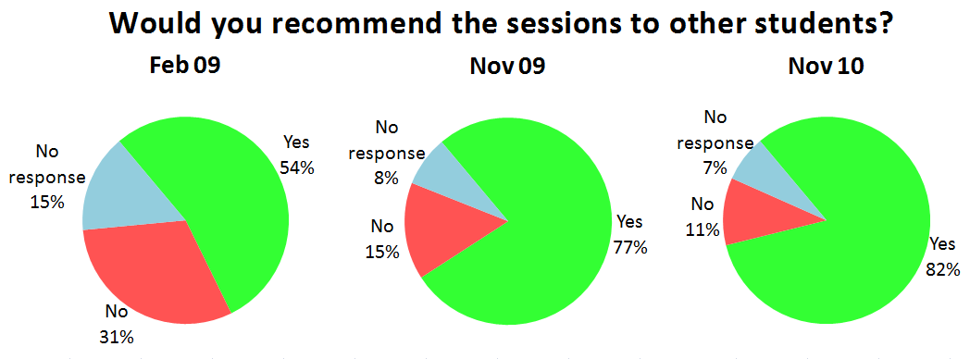

Although class attendance is highly recommended, whether face-to-face or online, participation is variable. It was important to establish whether the training would have a differential impact on students’ attendance (see Table 3).

Table 3
Participant attendance following the student training
Course start dates | Reported online  class attendance | Reported face-to-face  class attendance
February 2009 | 88% | 80%
November 2009 | 87% | 74%
November 2010 | 95% | 80%

The majority of respondents, answering in the early weeks of their course, reported on their attendance at class, with online participation comparing favourably with face-to-face. The extremely high figure for attendance at online classes in the final set (95%) suggests strongly that the changes introduced into the student training sessions (as described later) had indeed had an impact, although other factors are also likely to have contributed, for example greater experience and increased confidence among teachers.

Comparing Figures 6 and 7 with Figure 9 (below) it becomes apparent that more students found the “Elluminate for All” sessions useful to prepare for classes rather than with a view to meeting other students for independent study sessions. In other words, our short term aims were met, but not the medium term aim: only just over a third of respondents regarded this aspect as either ‘very useful’ or ‘fairly useful’, and there was no upward trend (see Figure 9).

Figure 9
Usefulness of the session for encouraging online independent study sessions

However, although students are encouraged to form independent study groups the numbers who actually do so have always been relatively low. As such the findings of the survey are actually much more positive than can be expected, even if they seem low by comparison with the data in Figures 6 and 7. Additional comments from some students support the positive attitude towards independent study groups, as in the following example:

“I meet with two study buddies every week and it is a great opportunity to go through any points we have difficulty with and also to practise speaking the language with each other.”

Additional Feedback (Student Comments)

A number of major themes also emerged from respondents’ open-ended comments. In fact, those from all three series contain similar themes: relative merits of the live online training and the text-based self-access materials, and an awareness of the affordances and pitfalls of the online virtual classroom versus face-to-face. There was also praise for the session facilitators.

A typical sentiment was that the live training sessions were helpful and confidence-building: “Using the technology for this course is harder than learning the Chinese, so I was grateful for this taster session.”

The online live training sessions proved popular and were compared favourably with the text-based training materials: “I found the written tutorial on how to use Elluminate very intimidating and difficult to understand.” and "It looked terrifying from the notes - but much easier when led through it step by step. It was suddenly fun!”

Several students expressed the view that the introductory sessions “should be 'compulsory' as otherwise a lot of time is lost learning [to use Elluminate] in the first tutorial”.

Some respondents expressed a preference for face-to-face classes: “Elluminate is good, but not as good as face-to-face sessions”, whilst others drew attention to sound or connection problems: “Too much technology and not reliable enough”. However there was also praise for the technological advances that mimicked so many aspects of meeting up in a classroom without the need to travel.

Changes in the Reaction and Re-planning Phases of the Cycle

In the light of student feedback and experience of running the successive series of sessions, changes were made in the organisation of the training. There were also practical changes (their timing, liaison with other stakeholders, roles within the training team) as well as modifications of the functionality of the online conferencing tool itself and improvements to the text-based self-access materials.

Preparation Materials

Students in adult distance learning can be assumed to have a range of preferred ways of learning, so different training options were made available: students could use self-access training materials or join the live online sessions, or use both ways of preparing themselves for online classes.

Although the text-based self-access materials for language students were widely used in comparison to other sources of advice or guidance for online learning (see Figure 5) they were also reviewed in the light of the feedback and subsequently rewritten. From 2011 the guidance notes became available in short form for students with computer experience and in a longer, illustrated version, with more basic computing terms explained. A Moodle quiz for self-checking preparedness for online classes was added, as was a short introductory video showing basic features of the software; these were of particular use to students favouring this style of learning, but potentially enjoyable to all students at some point. The relevant section in the university wide computing guide has also been progressively upgraded.

Organisation and Interfering Assumptions

While the online training sessions proved generally popular (see Figure 8), this was inevitably not the case for all participants. In the feedback from the November 2009 training sessions one student commented that it was “very cumbersome going through problems for 20 people’’. This may suggest a desire for a more individualised approach; the team was also aware that students with less computer experience might be in need of guidance as the year progressed. To cater for these needs a regular weekly drop-in session that ran throughout the year was introduced.

The first training sessions took place in a dedicated training site. Students wanting to join independent study groups had to move to a different website at the end of the session. They were given verbal instructions in the live sessions and whiteboards were set up with detailed instructions (see Figure 3).

Feedback indicated that planning and terminology had been informed by session designers’ and teachers’ experience of working with Lyceum’s ‘building’ structure, leading to an unhelpful transfer of routines. Students who had previously participated in classes in a different online medium (e.g. Skype, FlashMeeting) shared some of those expectations and transfers. A number of students reported going to the wrong online area: “I got confused as there was a [Departmental] website, Elluminate website and also actual…tutorial online website”. Others did not say what ‘room’ they had been in, but reported “nobody turned up to lead the session” and were not pleased.

To avoid this confusion locations were streamlined, access instructions were reworded and labelling was made more explicit. Both the general training session and the independent study session took place in the same online area. Breakout rooms were used for the independent study option in the second hour, as this did not require the student to disconnect and reconnect to a different website and a different area. To improve signposting, the name of the sessions was added in brackets to the title of the area where the sessions took place, as shown in Figure 10.

Figure 10
Department of Languages students’ website with link to the session.
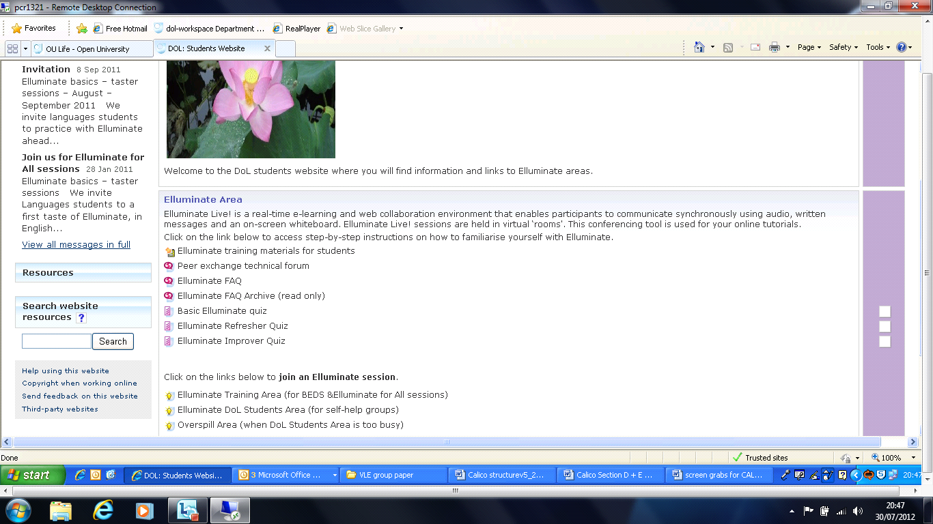

Practical Changes

The sessions were designed, as stated earlier, to increase confidence by providing some knowledge and practice in the basic functionalities of the tool prior to classes, so the series of training sessions had to be arranged at the start of the course. However, in response to student feedback (“you need to run the sessions early enough to save problems in tutorials…”) and to ensure as far as possible that students attended one before their first timetabled language class, the training sessions were brought forward to either just before or within the first week of the course.

Since the sessions were offered throughout the department teachers might assume that students attending their first class would be aware of basic functionalities of the tool. However, since only a quarter of eligible students opted to attend, teachers were made aware that there might be few experienced users. In order to meet the needs of all students, further sessions were subsequently offered later in the year. This was less of an issue in later years when language students were increasingly likely to have already done a course that used this particular tool.

The role of receptionist was formalised after the first series in response to high attendance at sessions and student feedback. Several students commented on “too many students” slowing down the session. So it was agreed that one facilitator designated as receptionist would greet students at arrival, distribute them into groups and assign them to a trainer and a training room. The role also included assisting colleagues by advising and directing latecomers, checking out initial sound problems or helping when someone was disconnected. By retaining the entry point to the online session, i.e. the main room as a staffed reception area and carrying out the induction sessions in separate breakout rooms in the same area, fewer disruptions occurred. The receptionist also became responsible for setting up the breakout rooms for the independent study sessions and labelling them, for example ‘Beginners’ French’, as students were directed to meet other students on the same course. The task of transferring students was also assigned to the receptionist.

Functionalities of the Tool

Every online conferencing tool has its particularities. For Elluminate there is a division of roles with different levels of permissions: the teacher typically has ‘moderator’ status and students ‘participant’ status. Moderators enjoy a larger number of permissions for the use of the various functionalities, including uploading content to the whiteboard, moving participants to different rooms and granting moderator status to participants, whilst participants have more restricted permissions.

Distance language learners are encouraged to become progressively more autonomous in their learning and an exclusively participant status is inconsistent with this. In the second iteration of the cycle a student expressed frustration that “I couldn’t get transferred [to the independent study room] when I wanted to be”. Others expressed the desire to be able to upload content for independent study sessions. As one student put it, this revolved around “the practical issue of who moderates, and how”, in other words learners taking increased control over their own learning.

As a result, and because the XX University is a large-scale user, the Department of Languages was able to request changes to the affordances of the tool in response to the need for change identified through the action research cycle. Changes were made to what participants could do for themselves in their online conferencing areas, in the first instance enabling them to move independently between rooms. Subsequently a dedicated mailbox was set up for students who wished to lead independent study groups to request moderator status. A further development was in 2012 the creation of a student area where all users became moderators on entry and could upload content for their own sessions; a development that favoured increased learner autonomy.

Conclusion

Our systematic evaluation and research has allowed us to make changes at different levels to our training programme (see Table 4), and also to draw further-reaching conclusions. By extrapolating from our own situation, we hope to be able to provide recommendations that can be useful for other institutions planning to support their learners’ experience of online language learning.

Table 4
Changes implemented
Change on different levels | Action | Outcome
Preparatory | text-based training materials were progressively revised and updated, integrating more interactive elements (e.g. quizzes) | allow for different learner types to engage with self-training prior to the online session
Practical and organisational | changes to timing, number of participants in the training sessions and use of online spaces  organisation of sessions, introduction of a receptionist  the allocation of moderator function to independent study group organisers | allow for more flexibility  and ease of access  streamline online training sessions; further support for participants  allow independent study groups full use of tool; support learner autonomy
Functional | changes to the tool itself were negotiated with university representatives and with the software company | make tool more democratic; allow students independent access and movement
Conceptual | changes to the trainers’ own understanding of the metaphor underlying the tool used (“college building” vs. “online session”)  changes to the explicit and implicit descriptions and organisation of training session | avoid the use of confusing instructions to students; avoid transfer of outdated practice  adapt all materials to new tool and disambiguate instructions

The two short term aims of the training programme, as stated in the section on Background and Context of the Study above, were introducing the basic functionality of the online teaching tool and building students’ confidence in its use. Both these aims have been achieved through the training programme. A further aim was encouraging students to form independent study groups. This did not rank so highly in the evaluation. Students indicated in their feedback that they appreciated both text-based and technological support but the deciding factor in joining online sessions was the human element, i.e. the support from trainers and peers during live online sessions. This seemed also to have played a role in their decision to continue with online classes after the training.

The training, as it developed over time and in response to students’ feedback (the reaction stage), covered most of the implications for learner training mentioned in Table 1. The training covered basic skills. More advanced skills (e.g. enhancing social presence) were touched upon but remained to be developed elsewhere: as mentioned above, following feedback and suggestions from students, weekly Q & A sessions were introduced from early 2010 onwards, to meet the advanced training needs of teachers as well as students.

One of the limitations of our findings is that our evaluative feedback is not an objective or reliable representation of the overall student cohort on our courses. Students already able to use computers for their learning were of necessity overrepresented. As the invitation to the training, the training sessions themselves and the evaluation survey were all presented online at the beginning of the language courses, students who had no prior experience of using ICT for learning were far less likely to have participated. Hence most of the evaluative comments will have come from students with at least a minimal prior ICT competence. For future developments, however, this type of student is likely to be much more common and therefore findings from our research can be adapted to a wider range of settings.

The main conclusions to be drawn from our research are in four areas: a) transfer of routines, b) possible changes, c) underlying pedagogy, and d) particular needs of the language learners.

Conclusion (a): Transfer of Routines
The prior expertise of the online trainers can lead to a transfer of routines. This expertise consists of a number of elements: their experience of different online communication (CMC) tools; their understanding of the purpose of language classes as an opportunity for interactive speaking practice; their underlying pedagogical beliefs and knowledge. All these elements can provide help but can also constitute a hindrance to training. For example experienced Lyceum teachers clearly found it easy to transfer skills of online class management, facilitating interaction, mediating between different modes from one tool to another, but on the other hand our unquestioned transfer of the metaphor of the online “building” led to confusion and problems when explaining access to and structure of the new tool to learners. Some conscious re-training and re-wording of text-based training materials had to take place for these misconceptions to be clarified.

Recommendation (a).
This type of transfer of skills should be taken into account whenever new tools or new methods are introduced, and problems associated with this transfer should be counteracted by involving the teachers in their own reflective action research cycle about transferable and non-transferable skills and metaphors.

Conclusion (b): Possible Changes
The power to change the content and the approach to training, its organisation, and even the functionality of the tools used needs to be recognised. Users are in a position to influence the development of a tool even if the software is not open-source. If feedback is systematically collected and used, as in the case of an action research cycle, it can be influential in commercial settings, since software providers respond positively to reasonable demands from major users. Awareness of this option can be integrated into any collection of feedback and its evaluation.

Recommendation (b).
Learners should be advised that their responses are genuinely valued, and informed about the extent to which potential changes can be achieved following their feedback, e.g. not only to the practicalities and organisation of training, but even to the functionality of the tools. However the potential limitations to change should also be recognised; some changes may be overtaken by rapid developments in other areas of the ICT world. User expectations need to be managed.

Conclusion (c): Underlying Pedagogy
Clarity regarding the pedagogy underpinning the training is important for the message given to students. In our case, adopting a constructivist approach matches the use of Moodle as a Virtual Learning Environment, the biographical and educational background of our students as mature adults, the necessities of language learning involving risk-taking and an outgoing, communicative attitude. It also matches the socio-cultural direction of the majority of our research and teaching efforts. This harmonisation of approach has made it possible to concentrate our training efforts in the same direction: towards self-training provision for students, encouraging every effort to form independent study groups to practise and develop autonomous learning in a social online setting.

Recommendation (c).
The pedagogical approach decided upon will influence not only the immediate training sessions, but will have far-reaching consequences including the choice of online tools used; for example a pedagogy based on equality of interaction in an online setting, as was the case for Lyceum classes, might be difficult to adapt to a less democratic online tool that distinguishes much more sharply between the roles of teacher and learner, e.g. Elluminate with its “moderator” and limited “participant” functionality.

Conclusion (d): Particular Needs of Language Learners
Language learning constitutes a special case because there is an additional cognitive load for the student who has to take care of the language as well as the content when he/she speaks . This is exacerbated in an online environment with its limited socio-affective dimensions and social presence indicators. Any training provided for online language learners therefore needs to pay particular attention to strengthening learners’ confidence for online speaking. It also needs to make explicit the available compensatory modes (see Hampel & Stickler 2012) of the online tool, and make the training relevant for its intended purposes, i.e. online teacher-led classes or independent peer-led practice sessions, or other forms of communicative action online.

Recommendation (d).
Language teachers and trainers can learn from other educational users about technical aspects of online training, but equally they have very crucial lessons to pass on to colleagues:
- their awareness of the (increased) difficulties of projecting one’s social presence in an online communicative situation that takes place in the L2,
- their understanding of the necessity to compensate for the lack of certain features of face-to-face communication that might be reduced or unavailable in online sessions,
- their sensitivity to the online learner’s needs for support in developing and retaining confidence in the face of communicative difficulties and obstacles to meaning making.

The "Elluminate for All" sessions reported on here have helped many XX University language students take their first steps in using the synchronous web-conferencing environment in which some of their language classes take place. By providing these sessions we have helped enhance some of these students' general level of ICT competence and confidence. By subjecting this student training model to an action research cycle, as detailed in this paper, we have not only been able to improve it, but have also gained insights that have enabled us to make some recommendations for practitioners elsewhere.
References

Almeida d'Eça, T., & Gonzáles, D. (2006). Becoming a Webhead: Bridging the Gap from Classroom to Blended or Online Learning. CALICO, Special Issue, 23(3), 569-580.
Baumann, U. (1999). Deutsch als Fremdsprache an der Open University. Zeitschrift für Interkulturellen Fremdsprachenunterricht [Online], 4(1), 10 pp.
Baumann, U., Shelley, M., Murphy, L., & White, C. (2008). New challenges: the role of the tutor in the teaching of languages at a distance. Distances et savoirs, 6(3), 364-392.
Beaven, M., Emke, M., Ernest, P., Germain-Rutherford, A., Hampel, R., Hopkins, J., Stanojevic, M., & Stickler, U. (2010). Needs and Challenges for Online Language Teachers – The ECML Project DOTS. Teaching English with Technology: A Journal for Teachers of English, 10(2), 5-20.
Bee Bee, S., & Gardner, D. (2012). Crossing the borders in language learning through the use of web conferencing as an e learning tool. International Journal of Web Based Communities 8(1), 120-132.
Berge, Z. L. (1995). Facilitating Computer Conferencing: Recommendations from the Field. Educational Technology, 35(1), 22-30.
Berglund, T. Ö. (2009). Multimodal student interaction online: an ecological perspective. ReCALL, 21, 186-205.
Buckingham Shum, S., Marshall, S., Brier, J., & Evans, T. (2001, Jan 2001). Lyceum: Internet Voice Groupware for Distance Learning Paper presented at the Euro-CSCL: 1st European Conference on Computer-Supported Collaborative Learning, Maastricht, NL.
Checkland, P., & Holwell, S. (1998). Action Research: Its Nature and Validity. Systemic Practice and Action Research, 11(1), 9-21.
Coleman, J. A., & Furnborough, C. (2010). Learner characteristics and learning outcomes on a distance Spanish course for beginners. System, 38(1), 14-29.
Coleman, J. A., Hampel, R., Hauck, M., & Stickler, U. (2010). Collaboration and interaction: the keys to distance and computer-supported language learning. In G. S. Levine & A. Phipps (Eds.), Critical and Intercultural Theory and Language Pedagogy. . Florence, KY, USA: Cengage Learning.
Comas-Quinn, A. (2011). Learning to teach online or learning to become an online teacher: an exploration of teachers' experiences in a blended learning course. ReCALL, 23(3), 218-232.
Crookes, G. (1993). Action Research for Second Language Teachers: Going Beyond Teacher Research. Applied Linguistics, 14(2), 130-144.
Duensing, A., Stickler, U., Batstone, C., & Heins, B. (2006). Face-to-face and online interactions – is a task a task? . Journal of Learning Design, 2(1), 34 - 44.
Ernest, P., Guitert Catasus, M., Hampel, R., Heiser, S., Hopkins, J., Murphy, L., & Stickler, U. (2012). Online teacher development: collaborating in a virtual learning environment. CALL (Computer Assisted Language Learning), 24(3), 1-23.
Ernest, P., Heiser, S., & Murphy, L. (2011). Developing teacher skills to support collaborative online language learning [iFirst Article]. The Language Learning Journal, 1-18.
Ernest, P., & Hopkins, J. (2006). Coordination and Teacher Development in an Online Learning Environment. CALICO, Special Issue, 23(3), 551-568.
Felix, U. (2002). The web as a vehicle for constructivist approaches in language teaching. ReCALL, 14(1), 2-15.
Glasersfeld, E. v. (2007). Key Works in Radical Constructivism. Rotterdam / Taipei: Sense Publishers.
Gunawardena, C. N., & Zittle, F. J. (1997). Social presence as a predictor of satisfaction within a computer-mediated conferencing environment. American Journal of Distance Education, 11(3), 8-26.
Hampel, R., & de los Arcos, B. (2011). Interacting at a distance: Exploring the role of ICT in developing the learner-context interface in a university language programme. Paper presented at the EUROCALL 2011, Nottingham, UK
Hampel, R., & Hauck, M. (2004). Towards an Effective Use of Audio Conferencing in Distance Language Courses. Language Learning and Technology (LLT), 8(1), 66-82.
Hampel, R., & Stickler, U. (2005). New Skills for New Classrooms: Training tutors to teach languages online. CALL (Computer Assisted Language Learning), 18 (4), 311-326.
Hampel, R., & Stickler, U. (2012). The use of videoconferencing to support multimodal interaction in an online language classroom. ReCALL 24(2), 116-137.
Harasim, L. M. (1990). Online Education: An Environment for Collaboration and Intellectual Amplification. In L. M. Harasim (Ed.), Online Education (pp. 39-64). New York, Westport, London: Praeger.
Hassan, X., Hauger, D., Nye, G., & Smith, P. (2005). The use and effectiveness of synchronous audiographic conferencing in modern language teaching and learning (online language tuition): a systematic review of available research. Research Evidence in Education Library. London: EPPI-Centre, Social Science Research Unit, Institute of Education, University of London.
Hauck, M., & Stickler, U. (2006). What Does It Take to Teach Online? CALICO, 23(3), 463-476.
Hawkins, E. W. (1981). Modern Languages in the Curriculum. Cambridge: Cambridge University Press.
Heins, B., Duensing, A., Stickler, U., & Batstone, C. (2007). Spoken interaction in online and face-to-face language tutorials. CALL (Computer Assisted Language Learning), 20(3), 279-295.
Hurd, S. (2001). Managing and supporting language learners in open and distance learning environments. In M. Mozzon-McPherson & R. Vismans (Eds.), Beyond language teaching towards language advising (pp. 135-148). London, UK: CILT Publications.
Lantolf, J. P. (2000). Introducing sociocultural theory. In J. P. Lantolf (Ed.), Sociocultural theory and second language learning. (pp. 1-26). Oxford, England: Oxford University Press.
Levy, M. (1998). Two conceptions of learning and their implications for CALL at the tertiary level. ReCALL, 10(1), 86-94.
Lewis, T. (2006). When Teaching is Learning: A Personal Account of Learning to Teach Online. CALICO, Special Issue, 23(3), 581-601.
Liu, M., Moore, Z., Graham, L., & Lee, S. (2003). A Look at the Research on Computer-Based Technology Use in Second Language Learning: A Review of the Literature from 1990-2000. Journal of Research on Technology in Education, 34(3), 250-273.
Lowenthal, P. R. (2010). The Evolution and Influence of Social Presence Theory on Online Learning. In T. T. Kidd (Ed.), Online Education and Adult Learning: New Frontiers for Teaching Practices (pp. 124-139). Hershey, PA: IGI Global.
McDonough, K. (2006). Action Research and the Professional Development of Graduate Teaching Assistants. The Modern Language Journal, 90(1), 33-47.
Nicolson, M., Murphy, L., & Southgate, M. (Eds.). (2011). Language Teaching in Blended Contexts. Edinburgh: Dunedin Academic Press.
O'Rourke, B. (2008). The other C in CMC: What alternative data sources can tell us about text-based synchronous computer mediated communication and language learning. Computer Assisted Language Learning, 21(3), 227-251.
Open University. (2010). 2009-2014 Curriculum Strategy, Senate, January 2010. Milton Keynes: The Open University.
Prawat, R. S., & Floden, R. E. (1994). Philosophical Perspectives on Constructivist Views of Learning. Educational Psychology, 29(1), 37-48.
Prensky, M. (2001). Digital Natives, Digital Immigrants. On the Horizon, 9(5), 1-6.
Rosell-Aguilar, F. (2006). Online tutorial support in open distance learning through audio-graphic SCMC: tutor impressions. JALT-CALL Journal, 2(2), 37–52.
Salmon, G. (2004). E-Moderating: The Key to online teaching and learning.: Routledge.
Satar, H. M. (2010). Social presence in online multimodal communication: a framework to analyse online interactions between language learners. PhD, The Open University, Milton Keynes.
Shield, L., Hauck, M., & Hewer, S. (2001). Talking to strangers - the role of the tutor in developing target language speaking skills at a distance. Paper presented at the Untélé 2000.
Short, J., Williams, E., & Christie, B. (1976). The social psychology of telecommunications. London: John Wiley & Sons.
Smith, B. (2010). Employing Eye-Tracking Technology in Researching the Effectiveness of Recasts in CMC. Directions and Prospects for Educational Linguistics. In F. M. Hult (Ed.), (Vol. 11, pp. 79-97): Springer Netherlands.
Stickler, U., Batstone, C., Duensing, A., & Heins, B. (2004). Distance and Virtual Distance: Preliminary results of a study of interaction patterns in synchronous audio graphic CMC and face-to-face tutorials in beginners' language tutorials. Proceedings of the 6th International Symposium on Applied Linguistics and Language Teaching (pp. 740-750). Beijing and Shanghai: University of Northern Iowa.
Stickler, U., Batstone, C., Duensing, A., & Heins, B. (2007). Distant Classmates: speech and silence in online and telephone language tutorials. EURODL, II.
Stickler, U., Ernest, P., Beaven, T., Emke, M., Germain-Rutherford, A., Hampel, R., Hopkins, J., & Stanojevic, M.-M. (2010). Introduction to the Special Issue of Teaching English with Technology. Teaching English with Technology: A Journal for Teachers of English, 10(2), n.p. online.
Stickler, U., & Hampel, R. (2010). CyberDeutsch: Language production and user preferences in a Moodle VLE. CALICO, 28(1), 49-73.
Stockwell, G. (2007). A review of technology choice for teaching language skills and areas in the CALL literature. ReCALL, 19, 105-120.
Thomas, P., Carswell, L., Price, B., & Petre, M. (1998). A holistic approach to supporting distance learning using the Internet: transformation, not translation. British Journal of Educational Technology, 29, 149–161.
Thorne, S. L. (2005). Epistemology, Politics, and Ethics in Sociocultural Theory. The Modern Language Journal, 89(3), 393-409.
Vygotsky, L. S. (1978). Mind in Society: The development of higher psychological processes. Cambridge, Mass.: Harvard University Press.
Wang, Y. (2004). Distance Language Learning: Interactive Fourth-generation Internet-based Videoconferencing. CALICO, 21(2), 373-395.
Wang, Y., & Chen, N.-S. (2007). Online Synchronous Language Learning: SLMS over the Internet. Innovate, 3(3), 8 pages (online).
Wang, Y., & Chen, N.-S. (2009). Criteria for evaluating synchronous learning management system: arguments from the distance language classroom. CALL (Computer Assisted Language Learning), 22(1), 1-18.
Wang, Y., Chen, N.-S., & Levy, M. (2010). Teacher training in synchronous cyber face-to-face classroom: characterizing and supporting the online teachers' learning process. CALL (Computer Assisted Language Learning), 23(4), 277-293.
Wertsch, J. V. (2007). Mediation. In H. Daniels, M. Cole & J. V. Wertsch (Eds.), The Cambridge Companion to Vygotsky (pp. 178-192). Cambridge: Cambridge University Press.
Wertsch, J. V., & Tulviste, P. (1992). L.S.Vygotsky and Contemporary Developmental Psychology. Developmental Psychology, 28(4), 548-557.
Yamada, M., & Akahori, K. (2007). Social presence in synchronous CMC-based language learning: How does it affect the productive performance and consciousness of learning objectives? CALL (Computer Assisted Language Learning), 20(1), 37-65.
Yamada, M., & Akahori, K. (2009). Awareness and performance through self- and partner’s image in videoconferencing. CALICO Journal, 27(1), 1–25.

Appendix: Online Feedback Questionnaire

Welcome!

You recently registered for an “Elluminate for All” session. Now the sessions are finished and the course is well underway, we would value your feedback as this will help us with planning future sessions.

It will take no more than 10 minutes.

Thank you!

1 Did you attend the session?
- yes
- no

2 If you didn’t attend, was this due to
- being unavailable on the day?
- being unable to access the session?
- accessing a room with no session taking place?

3 Do you have a home computer?
- yes
- no

4 Do you use a computer for
- word processing?
- spread sheets?
- computer games?
- Skype?
- YouTube?
- News?
- MSN/instant messaging?

5 Do you have broadband at home?
- yes
- no

6 Do you use a computer at work?
- yes
- no
- not applicable

7 Since the start of the course have you
- attended any face-to-face classes?
- attended any online classes using Elluminate?
- read messages on the course forum?
- posted messages on the course forum?

8 For advice or guidance with your online learning have you
- used the XX University computer guide?
- used guidance notes for students, from your course website?
- asked your tutor?
- contacted student support at your Regional/National centre?
- phoned the computing helpdesk?
- other? (please specify)

9 How useful was the Elluminate for All session in ……

● showing you how the online tutorials system works?
º very ° fairly º not very ° not at all

● giving you confidence to attend online tutorials?
º very ° fairly º not very ° not at all

● encouraging you to meet other students for independent study sessions?
º very ° fairly º not very ° not at all

10 Would you recommend Elluminate for All session to other students?
- yes
- no

Please comment on your answer (free text)

Thank you very much for your feedback!

“The ability to work collaboratively with others at a distance using ICT” together with self-reliance and a capacity for independent study, form part of the Open University’s approach to graduateness (2009-2014 Curriculum Strategy, Senate, January 2010 ).
Elluminate is now merged with Wimba and Blackboard Collaborate.

