Figures

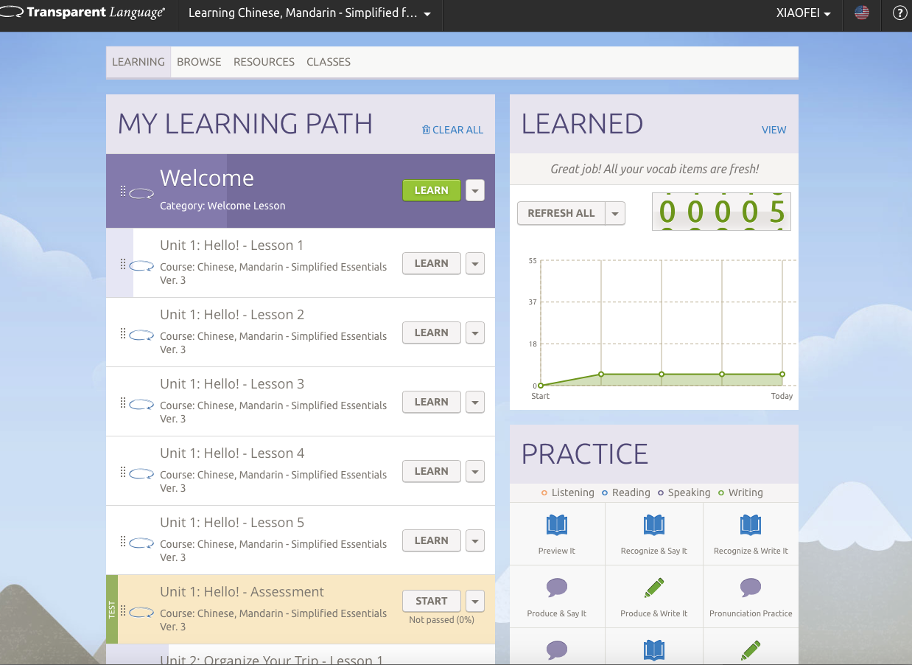
Figure 1: The main page of Chinese learning on Transparent Language
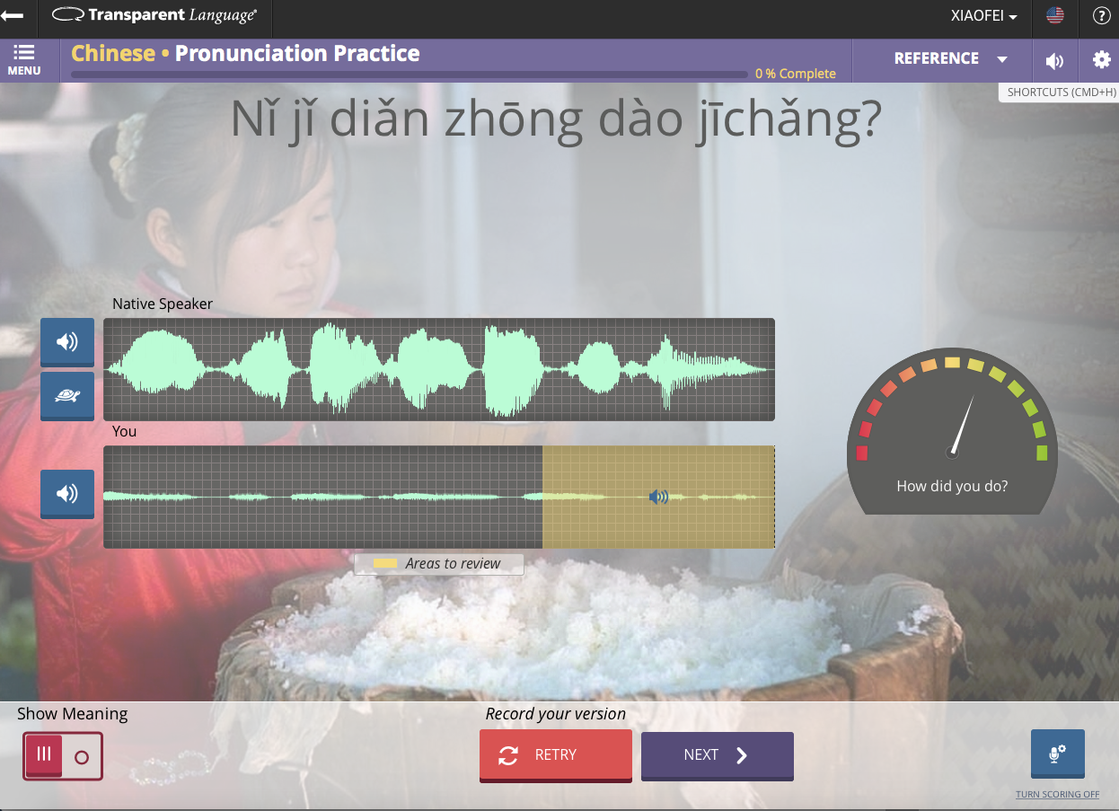
Figure 2: Voice recording feature of Transparent Language

